Coding Assessment

Name: Jeevan Sai Badana

Mail: [jeevansai100@gmail.com](mailto:jeevansai100@gmail.com)

Date: 21-02-2024

**Db coding assessment question 1**

1.Exploratory data analysis (EDA) in Databricks &Visualizing data in Databricks

Solution:

* Exploratory Data Analysis (EDA) and data visualization are important steps in understanding your data and deriving insights from it.
* Databricks provides a powerful platform for performing these tasks using languages like Python, SQL, and Scala along with libraries like Pandas, Matplotlib, Seaborn, and others for visualization.

Here's a basic example of performing EDA and visualization using Python in a Databricks notebook:

For this purpose first we create a cluster in azure databricks and then create a notebook

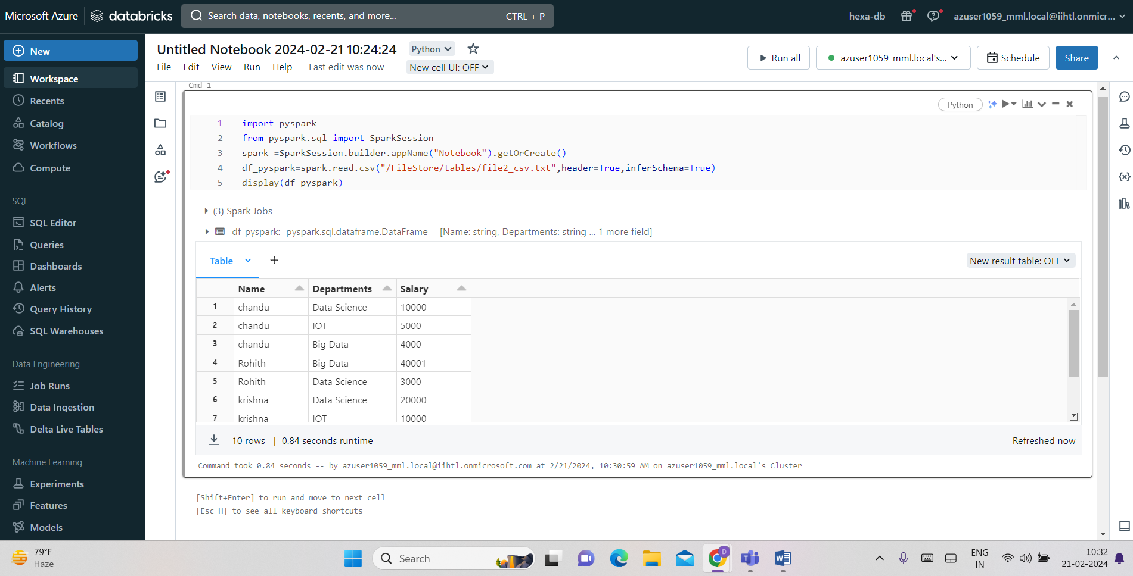

Using display we can visualize the data as below we select x-axis and y-axis and display data in graphs

